Experiment No :- 04

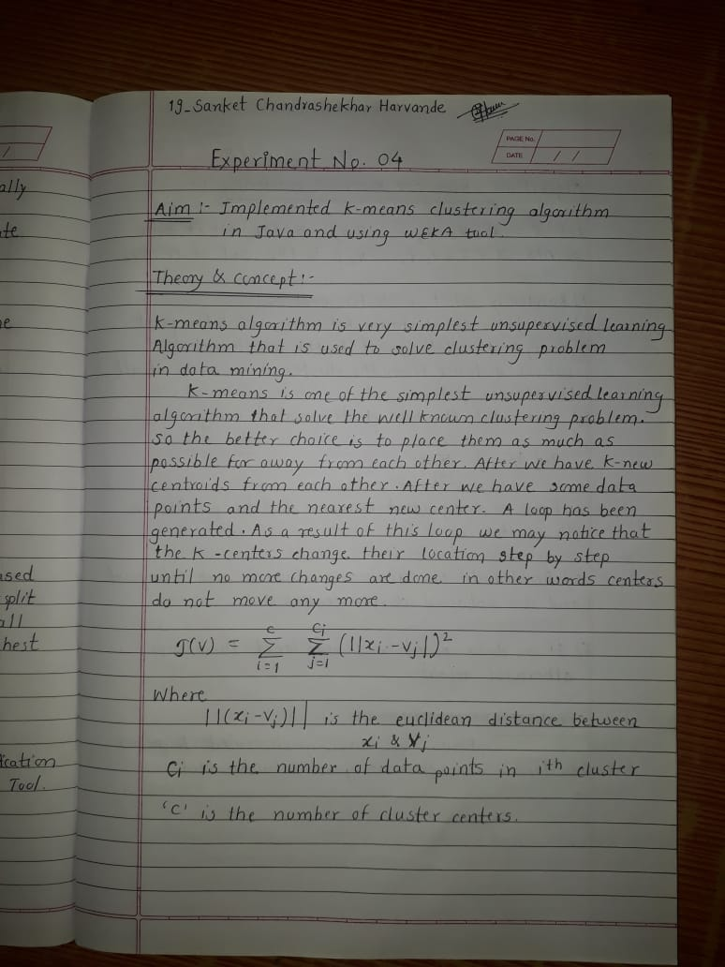

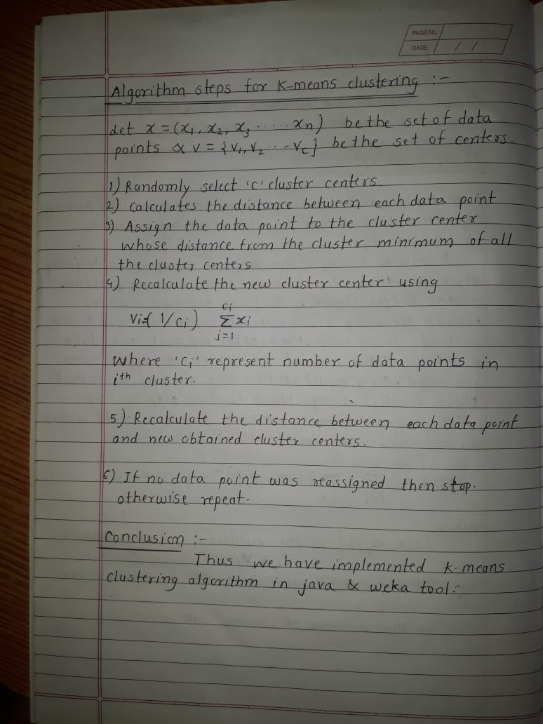

# Using Java :-

//Program

import java.util.*; class k_means

{

static int count1,count2,count3; static int d[];

static int k[][]; static int tempk[][]; static double m[]; static double diff[]; static int n,p;

static int cal_diff(int a) // This method will determine the cluster in which an element go at a particular step.

{

int temp1=0; for(int i=0;i<p;++i)

{

if(a>m[i]) diff[i]=a-m[i]; else diff[i]=m[i]-a;

}

int val=0;

double temp=diff[0]; for(int i=0;i<p;++i)

{

if(diff[i]<temp)

{

temp=diff[i]; val=i;

}

}//end of for loop return val;

}

static void cal_mean() // This method will determine intermediate mean values

{

for(int i=0;i<p;++i)

m[i]=0; // initializing means to 0 int cnt=0;

for(int i=0;i<p;++i)

{

cnt=0;

for(int j=0;j<n-1;++j)

{

if(k[i][j]!=-1)

{

m[i]+=k[i][j];

++cnt;

}}

m[i]=m[i]/cnt;

}

}

static int check1() // This checks if previous k ie. tempk and current k are same.Used as terminating case.

{

for(int i=0;i<p;++i) for(int j=0;j<n;++j) if(tempk[i][j]!=k[i][j])

{

return 0;

}

return 1;

}

public static void main(String args[])

{

Scanner scr=new Scanner(System.in);

/* Accepting number of elements */ System.out.println("Enter the number of elements "); n=scr.nextInt();

d=new int[n];

/* Accepting elements */ System.out.println("Enter "+n+" elements: "); for(int i=0;i<n;++i)

d[i]=scr.nextInt();

/* Accepting num of clusters */ System.out.println("Enter the number of clusters: "); p=scr.nextInt();

/* Initialising arrays */ k=new int[p][n]; tempk=new int[p][n]; m=new double[p]; diff=new double[p];

/* Initializing m */ for(int i=0;i<p;++i) m[i]=d[i];

int temp=0; int flag=0; do

{

for(int i=0;i<p;++i) for(int j=0;j<n;++j)

{

k[i][j]=-1;

}

for(int i=0;i<n;++i) // for loop will cal cal_diff(int) for every element.

{

temp=cal_diff(d[i]); if(temp==0) k[temp][count1++]=d[i]; else

if(temp==1) k[temp][count2++]=d[i]; else

if(temp==2) k[temp][count3++]=d[i];

}

cal_mean(); // call to method which will calculate mean at this step. flag=check1(); // check if terminating condition is satisfied. if(flag!=1)

/*Take backup of k in tempk so that you can check for equivalence in next step*/ for(int i=0;i<p;++i)

for(int j=0;j<n;++j) tempk[i][j]=k[i][j];

System.out.println("\n\nAt this step"); System.out.println("\nValue of clusters"); for(int i=0;i<p;++i)

{

System.out.print("K"+(i+1)+"{ ");

for(int j=0;k[i][j]!=-1 && j<n-1;++j)

System.out.print(k[i][j]+" ");

System.out.println("}");

}//end of for loop System.out.println("\nValue of m "); for(int i=0;i<p;++i)

System.out.print("m"+(i+1)+"="+m[i]+" ");

count1=0;count2=0;count3=0;

}

while(flag==0);

System.out.println("\n\n\nThe Final Clusters By Kmeans are as follows: "); for(int i=0;i<p;++i)

{

System.out.print("K"+(i+1)+"{ ");

for(int j=0;k[i][j]!=-1 && j<n-1;++j)

System.out.print(k[i][j]+" ");

System.out.println("}");

}

}

}

# OUTPUT

Enter the number of elements 8

Enter 8 elements:

2 3 6 8 12 15 18 22

Enter the number of clusters:

3

At this step Value of clusters K1{ 2 }

K2{ 3 }

K3{ 6 8 12 15 18 22 }

Value of m

m1=2.0 m2=3.0 m3=13.5

At this step Value of clusters K1{ 2 }

K2{ 3 6 8 }

K3{ 12 15 18 22 }

Value of m

m1=2.0 m2=5.666666666666667 m3=16.75

At this step Value of clusters K1{ 2 3 }

**Using WEKA:-**

